Draft Content: Sharing the Millennium Fellowship
Background
The United Nations Academic Impact and MCN proudly present the Millennium Fellowship. This program convenes, challenges, and celebrates student leadership for UN goals. In 2018, 402 Millennium Fellows collectively advanced all 17 Sustainable Development Goals and positively impacted the lives of 393,449 people in 13 nations. Over 7,000 young leaders on 1,209 campuses in 135 nations applied for the Class of 2019. This is a robust global network.

Please find draft content for email outreach and social media outreach below. You can view press from campuses around the world here. If you need any additional content, please reach out to fellowship@mcnpartners.org and it can be provided.

DRAFT CONTENT
(Note for social media posts: there are two n's in Millennium - noting to all our partners as it is often misspelled!)

DRAFT EMAIL

Subject: Recognizing students’ global leadership: Millennium Fellowship

The United Nations Academic Impact and MCN proudly present the Millennium Fellowship. This program convenes, challenges, and celebrates bold student leadership advancing the Sustainable Development Goals on campus and in communities. As a Millennium Fellow, you will hone skills, take concrete action, and earn a certificate of recognition from United Nations Academic Impact and MCN. There is no cost for selected students. Undergraduate leaders should apply as soon as possible (rolling admissions, Class of 2020 will run August-December 2020).

DRAFT FACEBOOK POST

#1 (Insert image included below)
Student leaders: United Nations Academic Impact and MCN present the #MillenniumFellowship. Take your social impact to the next level: http://www.millenniumfellows.org

OR
(Insert image included below)
Student leaders: United Nations Academic Impact and MCN present the #MillenniumFellowship. Make the Sustainable Development Goals your own: http://www.millenniumfellows.org

DRAFT TWITTER POST

(Insert image included below - tag @ImpactUN and @mcnpartners in photo)
Student leaders: United Nations Academic Impact and MCN present the #MillenniumFellowship. Take your social impact to the next level: http://www.millenniumfellows.org

OR
(Insert image included below - tag @ImpactUN and @mcnpartners in photo)
Student leaders: United Nations Academic Impact and MCN present the #MillenniumFellowship. Make the Sustainable Development Goals your own: http://www.millenniumfellows.org

DRAFT INSTAGRAM POST
(Insert image included below)

Student leaders: United Nations Academic Impact and MCN present the #MillenniumFellowship. Make UN goals reality on campus and in community. Become a Millennium Fellow: millenniumfellows.org (or link in bio)

OR
Student leaders: United Nations Academic Impact and MCN present the #MillenniumFellowship. Make the Sustainable Development Goals your own: http://www.millenniumfellows.org

Millennium Fellowship Logo Below

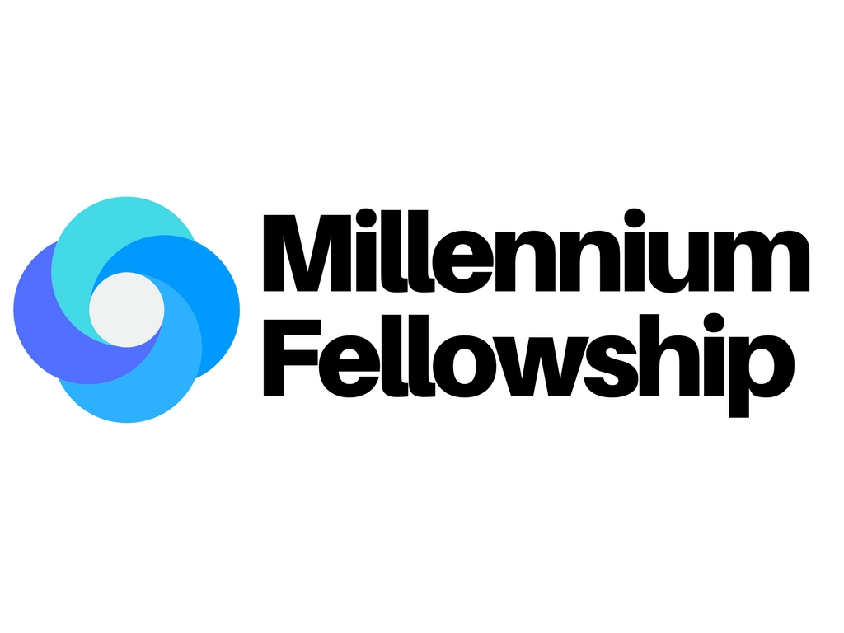

More images:

Image 1: Social Media Posts

Image 2: Social Media Story (Instagram Story, FB story, Snapchat Story)

2019 Content from United Nations Academic Impact and MCN:
- United Nations Academic Impact article about the program here and here.
- United Nations Academic Impact tweet here, Facebook post here.

2018 Content from United Nations Academic Impact and MCN:
- United Nations Academic Impact tweets about program here
- United Nations Academic Impact Facebook post here
- MCN Tweet here, Facebook post here, Instagram post here
- Statement on Partnership in English, Chinese, French, Russian, and Spanish.
- United Nations Academic Impact spotlights three Millennium Fellowship Projects - article available in English, French, and Spanish.

2018 Additional content:
- UN Women tweets about #MillenniumFellowship here
- Actor Terry Crews tweets about the program here
- Actor Tony Goldwyn tweets about the program here
- 8th UN Secretary-General Ban Ki-moon’s video message on Facebook here and YouTube here

